Club News
Hudson Valley Explorer
http://www.greattreasure.com Fall 2010
In Memoriam
Long time detectorist and P/WMD&AS member Mike Dziadik died September 2 at the W. Haven, CT VA Hospital. A Marine veteran, Mr. Dziadik was buried with full military honors Saturday, September 11, 2010 at Mountain Meadows Cemetery in Seymour, CT. Condolences from the club have been sent to his widow Janice Dziadik. Anyone wishing to make a personal memorial may do so to the Hospice Unit of the West Haven VA Hospital through Anthony V. Chepulis Funeral Home, 47 Washington Ave. Seymour, CT 06483.

Cape Cod Weekend
The weather was beautiful when 3 members arrived with high expectations and the weather remained beautiful for the entire weekend. The only find of note was this 14kt rose gold band ring found by Paul Maloney 4-1/2" below the sand.

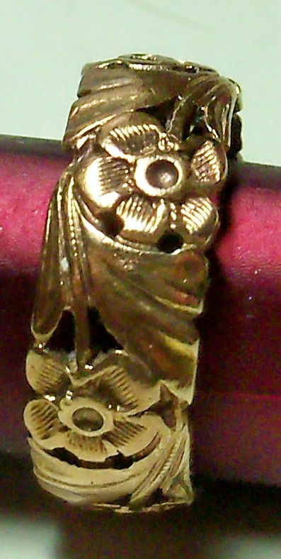
14 K Rose Gold band ring found on Cape Code 9/11/2010

Officers

President

Ted Izzo

Vice President

Rich Markert

Putnam/Westchester Metal Detectorists and Archeological Society

Secretary
Conrad Rasinski

Treasurer
Larry Cohen

Librarian
Carol Mayers

Finds of the Month
Todd Olsen

Site Research Coordinator

TBD

Newsletter Editor - Webmaster
Paul Maloney

Treasure in the News

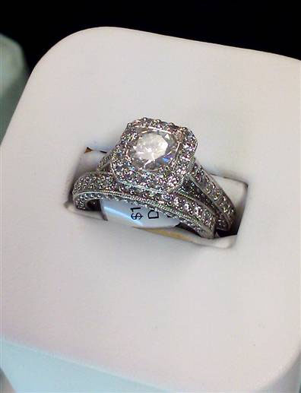

Matt Cawley attached this $9,000 family heirloom ring to a sand dollar as part of a surprise proposal to Stacey Scanlon — but it came loose and fell among the rocks on a jetty. A lifeguard suspects the ring has washed out to sea.

By Michael Inbar
TODAYshow.com contributor
Updated 8/12/2010 6:24:46 PM ET
A romantic engagement surprise turned into a moment of horror for a prospective Massachusetts bride Monday when she fumbled a $9,000 diamond engagement ring — and it disappeared down a rocky jetty below her.
Matt Cawley, a 31-year-old restaurateur from Deadham, Mass., was trying to make his proposal to 30-year-old schoolteacher Stacey Scanlon a memorable one. So he tied the family heirloom to an oversize sand dollar and placed it on the jetty at Bass River Beach in Yarmouth.
Cawley then took Scanlon for a stroll along the jetty, where he directed her attention to the sand dollar. “I had no idea whatsoever; we were just going on a morning walk,” Scanlon told TODAYshow.com.
When she saw the sand dollar, Scanlon said, “I went to pick it up and I heard something fall; I thought it was a rock. It was a rock! Just not exactly the rock I was expecting.”
Detached from the sand dollar, the ring tumbled down through the rocks. “It was a scene out of a movie: I can’t even describe it — it was unbelievable,” Cawley told TODAYshow.com. “I said as it was falling: ‘Stacey! The ring!’ And she said: ‘Wait - what ring?’ ”
“It was the worst feeling in the world,” Cawley added. “I won’t put it up there with a death, but I was in shock.”
No stone unturned
Little wonder: Not only was the diamond valuable — it was a gift from a family friend. After it fell, a thorough search began. Lifeguards, passersby, and even a retiree with a metal detector pitched in. One man even cut his head open while helping out and had to be bandaged by lifeguards.
“For four hours we all just worked and worked and worked, moving 200- to 300-pound boulders,” Cawley told TODAYshow.com. “It really shows you how nice people truly are; perfect strangers just helping out.”
But it was all for naught. Empty cans, fishing lines and lures were found wedged between the rocks, but no engagement ring. Lifeguard Matt Peterson told the Cape Cod Times that the ring may have washed out to sea.
“The tide does come up, and we tried to get it before the high tide reached where we were looking,” Peterson said. “As soon as the water came up, we had to stop.”
Silver lining
Meanwhile, family members who had secretly gathered to celebrate Cawley’s proposal were wondering what had happened, not knowing of the hours-long search. “This whole romantic thing was supposed to be on the pier, and I ended up asking her in the back of my cousin's Mazda,” Cawley told TODAYshow.com.
Despite the morning’s traumatic events, Scanlon said yes. “His cousin, back at the house, was so sweet,” she told TODAYshow.com. “She made me a string ring ... It's multicolored, purple and orange. It's one of those braided bracelets.”
But though there was no diamond, there was a silver lining: Unbeknownst to Cawley, just three days before the ill-fated proposal, his mother had had the ring insured. “I swore my mom knew,” Cawley told TODAYshow.com. “She insured the ring knowing something could happen. These things only happen to me.”
Now a jeweler is working on making a replica of the lost ring, with a replacement diamond, and the couple are thinking about a wedding in Cape Cod, hopefully in August. But, Scanlon emphasized, “definitely not near a jetty.”
Steve Veres contributed reporting to this story.
© 2010 MSNBC Interactive.
See page 5 for Finds Of The Month Entry Forms
Finds of the Month June 2010
USA Silver Coin – 1895S Barber Dime – Roy Roos
USA Non-Silver Coin – 1852 Large Cent – Roy Roos
Foreign Non-Silver Coin – 1785 Nova Constellatio – Conrad Rasinski
Foreign Silver Coin – 1775 1 Reale – Conrad Rasinski
Gold Jewelry - 14K Gold Necklace – Conrad Rasinski
Silver Jewelry – Silver Ring – Carol Mayers
Finds of the Month June 2010 (con’t)
Button – Virginia Flat Button – Dennis Luria
Medal – 1917 Chauffeur Badge – Roy Roos
Relic –Large Skeleton Key – Mike Spasiuk
Buckle – Colonial Shoe Buckle – Conrad Rasinski

Finds of the Month September 2010

USA Silver Coin - 1835 Capped Bust Dime - Roy Roos

USA Non-Silver Coin - 1868 2 Cent
Piece - Carol Mayers

Foreign Silver Coin - 1839 Turkish 1/2 Dime - Don Mayers

Foreign Non-Silver Coin -William III 1/2 pence - Don Mayers

Gold Jewelry - Diamond Ring / Tiffany Necklace - Tie - John Condon / Conrad Rasinski

Silver Jewelry - Sterling Silver Bracelet - Conrad Rasinski

Token - Sing, Sing Prison
Token - Roy Roos

Relics –
Crotol Bell - Roy Roos

Medal - Virgin Mary Miraculous Medal - Conrad Rasinski

Call for Classified Ads
Have equipment you are looking to buy, sell, or swap? Want to arrange a car pool to the Membership Meetings? Run your metal detecting-related classified ads in the Hudson Valley Explorer (the online version is included). It’s free, and your ad will run for two issues (6 months) before it needs to be renewed. For inclusion, Please send your ad to:
Paul Maloney 26 N. Third St. Or email the information to pemalon@optonline.net Include pictures if you have them, hard copy or digital acceptable.
Support Those Who Support Us
American Digger Magazine
P. O. Box 126
Acworth, GA 30101
Lost Treasure Magazine
Box 451589
Grove, OK 74345
http://www.losttreasure.com

Western & Eastern Treasures Magazine
P.O. Box 219
San Anselmo, CA 94979
http://www.treasurenet.com
1-800-999-9718
Hudson River Metal Detectors Detector ProTM
Innovative hunting concepts since 1996
1447 Route 44
Pleasant Valley, NY 12569
http://www.detectorpro.com
info@detectorpro.com
1-845-635-3488
Support Those Who Support Us (con’t)
Minelab USA
871 Grier Dr., Suite B1
Las Vegas, NV 89119
http://www.minelab.com/consumer
1-702-891-8809

White’s of Long Island, Inc.
240 Route 112
Pachogue, NY 11772
Phone/Fax 1-631-447-7196

Snows Metal Detectors
Authorized Tesoro Dealer
1-860-488-5694 – Joe
http://stores.ebay.com/snows-metal-detectors

Kellyco Metal Detector Superstore
1085 Belle Avenue
Winter Springs, FL 32708
1(888)535-5926

Valley Coins
Ed Zehall, Owner
37A New Haven Road
Seybridge Plaza, Rt. 67
East Seymour, CT 06483
http://www.angelfire.com/planet/valleycoins/index.htm zehallco@aol.com
1-203-888-1186
Buy – sell – trade US & World Coins, Paper Money, Gold & Silver Coins, Bars & Scrap..Confidential Appointments
Mon-Wed, Fri 10am – 5pm
Thur 10am – 8pm
Sat 10am – 4pm

J-Tech Industries
Custom Welding & Fabricating
Steel, Aluminum & Stainless Steel
130 Silvermine Road
Seymour, Ct 06483
Jason Lubinski
(203)545-9828

FMDAC Treasure Hunter’s Code of Ethics
I will always check federal, state, county, and local laws before searching. It is my responsibility to know the law.
I will respect private property and will not enter private property without the owner’s permission. Where possible, such permission with be in writing.
I will take care to refill all holes and try not to leave any damage.
I will remove and dispose of any and all trash and litter that I find.
I will appreciate and protect our inheritance of natural resources, wildlife, and private property.
I will, as ambassador for the hobby, use thoughtfulness, consideration, and courtesy at all times. I will leave gates as found.
I will build fires in designated or safe places only.
I will report to the proper authorities any individuals who enter and/or removes artifacts from federal Parks or state preserves.

Metal Detecting Permit
Information
Take the time to renew your permits now for Spring! See the list of locations where you may send to receive yearly metal detecting permits below. If possible, call first for any updates or instructions.
1. Palisades Interstate Park Commission Permit Section Bear Mountain, NY 10911-0427 ..................................$20.00 For: Harriman State Park (845)-786-2701
Lakes: Sebago, Tiorati & Welch
2. Long Island State Park Region Beaches Permit Office PO Box 247 Babylon, NY 11702.…………..……...…..$40.00 (631)-669-1000 ext. 223
3. City of New York Parks & Recreation Arsenal North 234 Fifth Ave. Room 213 New York, NY 10029.…...........................….FREE (212)360-2778
(MUST SEND IN COPY OF YOUR DRIVERS LICENCE)
4. Office of Parks, Recreation & Historic Preservation Taconic Region Staatsburg, NY 12580....................................$10.00 (845)889-4100 For: Lake Taghkanic, Rudd Pond & Canopus Beach
5. NY State Offices Parks Recreation & Historic Preservation Central Region 6105 East Seneca Turnpike Jamesville NY 13078-9516 …$10 (315)-492-1756

Tentative Schedule of Events for 2010*
*contingent on finalization of search agreement

Thursday, October 7, 7:00pm
Membership Meeting, Yorktown Heights, NY

Saturday, October 23, 9:00am
Rain Date October 24 Sunday
Search Outing Stormville, NY

Thursday, November 4, 7:00pm
Membership Meeting , Yorktown Heights, NY
Saturday, November 6, 10:00am*
Fall Classic Seeded Hunt, Fairfield, CT
Saturday, December 4, 7:00pm*
Annual Christmas Party
Ye Old Lantern Restaurant
728 Route 6
Mahopac, NY (845)628-7302

Finds of the Month Forms
Please use the forms below if you are going to place an item/s into the Finds of the Month competition (place your name on the back of each entry):
Category-----------------Find----------------------Location------------------
Category-----------------Find----------------------Location------------------
Category-----------------Find----------------------Location------------------
Category-----------------Find----------------------Location------------------
Category-----------------Find----------------------Location------------------
Category-----------------Find----------------------Location------------------
Category-----------------Find----------------------Location------------------
Category-----------------Find----------------------Location------------------
Category-----------------Find----------------------Location------------------
Category-----------------Find----------------------Location------------------
Category-----------------Find----------------------Location------------------
Category-----------------Find----------------------Location------------------
Category-----------------Find----------------------Location------------------
Category-----------------Find----------------------Location------------------
Category-----------------Find----------------------Location------------------
Category-----------------Find----------------------Location------------------
Category-----------------Find----------------------Location------------------
Category-----------------Find----------------------Location------------------
Category-----------------Find----------------------Location------------------
Category-----------------Find----------------------Location------------------
Category-----------------Find----------------------Location------------------
Category-----------------Find----------------------Location------------------
Category-----------------Find----------------------Location------------------
Category-----------------Find----------------------Location------------------
Category-----------------Find----------------------Location------------------
Category-----------------Find----------------------Location------------------
Category-----------------Find----------------------Location------------------
Category-----------------Find----------------------Location------------------
Category-----------------Find----------------------Location------------------
Category-----------------Find----------------------Location------------------
Category-----------------Find----------------------Location------------------
Category-----------------Find----------------------Location------------------
Category-----------------Find----------------------Location------------------
Category-----------------Find----------------------Location------------------
Category-----------------Find----------------------Location------------------
Category-----------------Find----------------------Location------------------
Category-----------------Find----------------------Location------------------

