Treasure in the News
Hudson Valley Explorer
http://www.greattreasure.com Spring 2010

Metal detectors hit beaches in search of treasure

By Gary Jeanfaivre, Gjeanfaivre@bcnnew.com

Published: 04:39 p.m., Wednesday, January 27, 2010
On Tuesday, when the wind from Monday's storm had died down a bit and the rain had passed, Don and Carol Mayers gathered their equipment and went to the beach. They put on their waterproof boots and winter jackets, picked up their metal detectors and hoped that the storm had washed up some treasure.
"Everyone complains about beach erosion, but idiots like us love it," Don said, with a hearty laugh.
Earlier in the day he had some luck at a beach in Milford. There, he found a silver ring and a mercury coin. The items were far from their original shining glory, but, for Don, it was a score.
The Mayers, residents of Oxford, are members of the Putnam / Westchester Metal Detectorists & Archaeological Society. Don is vice president and Carol serves as the organization's librarian.
Metal detecting may just be a hobby for the couple, but they are quite knowledgeable about various types of metal, the history of coins and technical terms.

Don explained that the silver coins they find are often in poor condition because of chemical reactions that take place over time. Silver reacts with the salt in the

Officers

President

Ted Izzo

Vice President

Rich Markert

Putnam/Westchester Metal Detectorists and Archeological Society

Secretary
Conrad Rasinski

Treasurer
Larry Cohen

Librarian
Carol Mayers

Finds of the Month
Todd Olsen

Site Research Coordinator

TBD

Newsletter Editor - Webmaster
Paul Maloney

Treasure in the News (con’t)
water and leeches out over time, leaving behind a corroded piece of metal that is only a semblance of its original shape and design.
Due to this process, many of the pieces of metal found are often quite fragile. In fact, some are so much so that they often disintegrate when the sand around them is disturbed by the shovel. Carol said this is called "ghosting."
Fortunately, a Standing Liberty Quarter she located on Jennings Beach remained intact. Don said this is a great find. Yet, according to the society's Web site, www.greattreasure.com, Carol is no stranger to great finds. Three items she located in September 2009 were named among the society's "Finds of the Month."
"Every once in a while we get lucky," Don said, looking out on the expansive stretch of sand before him at Jennings Beach. It was low tide -- prime time to search for buried treasure, as much more beach is exposed.
A few hundred feet away, Carol glided her metal detector across the sand's surface as walked up and down the beach - waiting for the beep that would signal the presence of something. The beeps were only audible to her. Both Carol and Don wear ear muffs that are connected to the metal detector. "We wear them so as not to bother anyone with the beeping," Don said.
He had a hit, dug up the sand with his small shovel-like tool and sifted through the sand for the metal object. No such luck; the signal was gone, with nothing to be found. He pushed the sand back into the hole and continued his slow pace along the beach.
Treasure in the News (con’t.)
A steady set of small waves crashed and rolled up toward Don's feet. A few dogs ran nearby, one in pursuit of a tennis ball and another after a group of seagulls, as their owners looked on.
"It's a lovely beach," Don said. "We appreciate the opportunity to come down here."
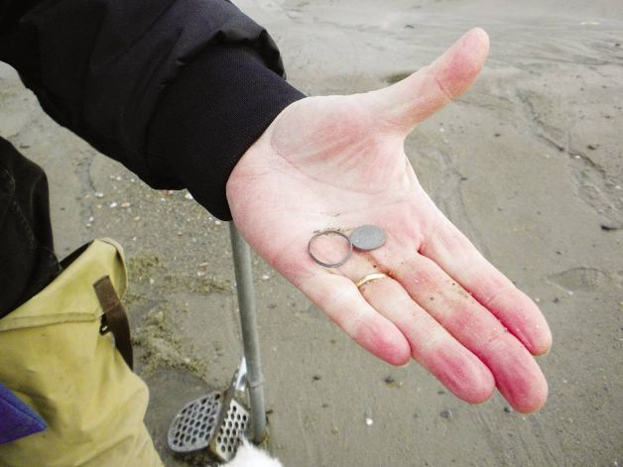
Don Mayers of Oxford displays a mercury coin and silver ring he found while at a beach in Milford on Tuesday. Photo: Gary Jeanfaivre / Fairfield Citizen
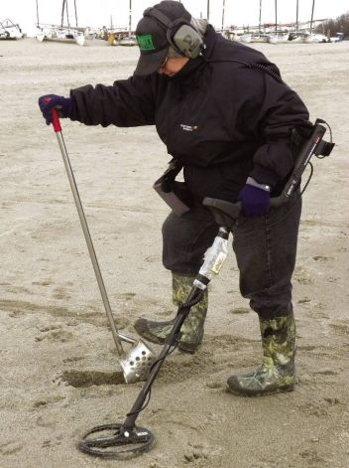
Carol Mayers of Oxford digs at the spot where her metal detector beeped on Tuesday at Jennings Beach in Fairfield. Photo: Gary Jeanfaivre / Fairfield Citizen
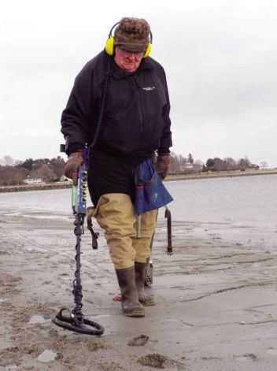
Don Mayers of Oxford glides his metal detector along the sand of Jennings Beach in Fairfield on Tuesday. Photo: Gary Jeanfaivre / Fairfield Citizen
New rules outlaw melting pennies, nickels for profit
Posted 12/14/2006 12:01 AM ET By Haraz N. Ghanbari, AP
The value of the metal in a nickel is now 6.99 cents, while the penny's metal is worth 1.12 cents, according to the U.S. Mint
By Barbara Hagenbaugh, USA TODAY
WASHINGTON — People who melt pennies or nickels to profit from the jump in metals prices could face jail time and pay thousands of dollars in fines, according to new rules out Thursday.
Soaring metals prices mean that the value of the metal in pennies and nickels exceeds the face value of the coins. Based on current metals prices, the value of the metal in a nickel is now 6.99 cents, while the penny's metal is worth 1.12 cents, according to the U.S. Mint.
That has piqued concern among government officials that people will melt the coins to sell the metal, leading to potential shortages of pennies and nickels.
"The nation needs its coinage for commerce," U.S. Mint director Ed Moy said in a statement. "We don't want to see our pennies and nickels melted down so a few individuals can take advantage of the American taxpayer. Replacing these coins would be an enormous cost to taxpayers."
There have been no specific reports of people melting coins for the metal, Mint spokeswoman Becky Bailey says. But the agency has received a number of questions in recent months from the public about the legality of melting the coins, and officials have heard some anecdotal reports of companies considering selling the metal from pennies and nickels, she says.
Under the new rules, it is illegal to melt pennies and nickels. It is also illegal to export the coins for melting. Travelers may legally carry up to $5 in 1- and 5-cent coins out of the USA or ship $100 of the coins abroad "for legitimate coinage and numismatic purposes."
Violators could spend up to five years in prison and pay as much as $10,000 in fines. Plus, the government will confiscate any coins or metal used in melting schemes.
The rules are similar to those enacted in the 1960s and 1970s, when metals prices also rose, the Mint said. Ongoing regulations make it illegal to alter coins with intent to commit fraud. Before today's new regulations, it was not illegal to melt coins.
Metals prices have skyrocketed worldwide in recent years in response to rising demand, particularly in rapidly growing China and India. Prices for zinc, which accounts for nearly all of the metal in the penny, have risen 134% this year, according to the London Metal Exchange. Even accounting for a recent decline, the price of copper is up 50% since the start of 2006. Nickels are produced from 75% copper and 25% nickel.
Although the Mint's new rules are immediately going into effect, the Mint will take comments from the public for a month.
The government has changed the composition of coins in response to rising metal prices. The penny, which was pure copper when it was introduced in 1793, was last changed in 1982.
. Metal Prices as of March 10, 2010

Gold $1124.70 /oz

Silver $ 17.41/oz

Platinum $1604.00 /oz

Copper $3.4110 /lb
Finds of the Month March 2010
USA Silver Coin - Conrad Rasinski 1853 Seated Dime
Gold Jewelry - Conrad Rasinski 14kt Signet Ring
Relic – Conrad Rasinski Revolutionary musket ball
Silver Jewelry – Al Kontis Mason's ring.
Call for Classified Ads
Have equipment you are looking to buy, sell, or swap? Want to arrange a car pool to the Membership Meetings?
Run your metal detecting-related classified ads in the Hudson Valley Explorer (the online version is included). It’s free, and your ad will run for two issues (6 months) before it needs to be renewed. For inclusion, Please send your ad to:
Paul Maloney 26 N. Third St. Or email the information to pemalon@optonline.net Include pictures if you have them, hard copy or digital acceptable.
Wanted to buy: Used Minelab Excalibur I or II water detector Joe Snow, 1(860)488-5694 or see me at the meeting.

Support Those Who Support Us
American Digger Magazine
P. O. Box 126
Acworth, GA 30101
Lost Treasure Magazine
Box 451589
Grove, OK 74345
http://www.losttreasure.com

Western & Eastern Treasures Magazine
P.O. Box 219
San Anselmo, CA 94979
http://www.treasurenet.com
1-800-999-9718
Hudson River Metal Detectors Detector ProTM
Innovative hunting concepts since 1996
1447 Route 44
Pleasant Valley, NY 12569
http://www.detectorpro.com
info@detectorpro.com
1-845-635-3488

Minelab USA
871 Grier Dr., Suite B1
Las Vegas, NV 89119
http://www.minelab.com/consumer
1-702-891-8809

White’s of Long Island, Inc.
240 Route 112
Pachogue, NY 11772
Phone/Fax 1-631-447-7196

Snows Metal Detectors
Authorized Tesoro Dealer
1-860-488-5694 – Joe
http://stores.ebay.com/snows-metal-detectors

Kellyco Metal Detector Superstore
1085 Belle Avenue
Winter Springs, FL 32708
1(888)535-5926

Valley Coins
Ed Zehall, Owner
37A New Haven Road
Seybridge Plaza, Rt. 67
East Seymour, CT 06483
http://www.angelfire.com/planet/valleycoins/index.htm zehallco@aol.com
1-203-888-1186
Buy – sell – trade US & World Coins, Paper Money, Gold & Silver Coins, Bars & Scrap..Confidential Appointments
Mon-Wed, Fri 10am – 5pm
Thur 10am – 8pm
Sat 10am – 4pm

J-Tech Industries
Custom Welding & Fabricating
Steel, Aluminum & Stainless Steel
130 Silvermine Road
Seymour, Ct 06483
Jason Lubinski
(203)545-9828

FMDAC Treasure Hunter’s Code of Ethics
I will always check federal, state, county, and local laws before searching.
It is my responsibility to know the law.
I will respect private property and will not enter private property without the owner’s permission. Where possible, such permission with be in writing.
I will take care to refill all holes and try not to leave any damage.
I will remove and dispose of any and all trash and litter that I find.
I will appreciate and protect our inheritance of natural resources, wildlife, and private property.
I will, as ambassador for the hobby, use thoughtfulness, consideration, and courtesy at all times. I will leave gates as found.
I will build fires in designated or safe places only.
I will report to the proper authorities any individuals who enter and/or removes artifacts from federal Parks or state preserves.

Metal Detecting Permit
Information
Take the time to renew your permits now for Spring! See the list of locations where you may send to receive yearly metal detecting permits below. If possible, call first for any updates or instructions.
1. Palisades Interstate Park Commission Permit Section Bear Mountain, NY 10911-0427 ..................................$20.00 For: Harriman State Park (845)-786-2701
Lakes: Sebago, Tiorati & Welch
2. Long Island State Park Region Beaches Permit Office PO Box 247 Babylon, NY 11702.…………..……...…..$20.00 (631)-669-1000 ext. 223
3. City of New York Parks & Recreation Arsenal North 234 Fifth Ave. Room 213 New York, NY 10029.…...........................….FREE (212)360-2778 (MUST SEND IN COPY OF YOUR DRIVERS LICENCE)
4. Office of Parks, Recreation & Historic Preservation Taconic Region Staatsburg, NY 12580....................................$10.00 (845)889-4100 For: Lake Taghkanic, Rudd Pond & Canopus Beach
5. NY State Offices Parks Recreation & Historic Preservation Central Region 6105 East Seneca Turnpike Jamesville NY 13078-9516 (315)-492-1756

Tentative Schedule of Events for 2010*
*contingent on finalization of search agreement

Thursday, April 1, 7:00 P.M.
Membership Meeting, Yorktown Heights, NY
Don and Carol Mayers will demonstrate gold panning while working gold dirt from Nome, AK.
APRIL 10th – Belmar, New Jersey. Premier Belmar Beach Blast sponsored by the East Coast Research & Discovery Association - 8:30 a.m. - 3:30 p.m., rain or shine, at the John Taylor Pavilion. For more information, contact Harold Lowenfels ECRDA 2010 Beach Blast, 2845 Lenox Street, Toms River, NJ 08755 or e-mail Art Pearson at artmds@verizon.net
Saturday, - April 17, 9:00am*
No rain date
Search Outing Patterson, NY
Thursday, May 6, 7:00pm
Membership Meeting, Yorktown Heights, NY
Saturday, May 15, 9:00am*
Rain Date Sunday, May 16*,
Search Outing Granite Springs, NY

Thursday, June 3, 7:00pm
Membership Meeting, Yorktown Heights, NY

Saturday, June 12, 9:00am*
Rain Date June 13 Sunday*
Search Outing Mahopac, NY

Thursday, September 9, 7:00pm
Membership Meeting, Yorktown Heights, NY

Saturday/Sunday, Sept. 11-12, 9:00am*
Search Outing TBD

Thursday, October 7, 7:00pm
Membership Meeting, Yorktown Heights, NY

Saturday, October 23, 9:00am*
Rain Date October 24 Sunday*
Search Outing Stormville, NY

Thursday, November 4, 7:00pm
Membership Meeting , Yorktown Heights, NY
Saturday, November 6, 10:00am*
Fall Classic Seeded Hunt, Fairfield, CT
Saturday, December 4, 7:00pm*
Annual Christmas Party
Ye Old Lantern Restaurant
728 Route 6
Mahopac, NY (845)628-7302

See Page 5 for Fall Classic Committee Sign Up Sheet

