Club News
Hudson Valley Explorer
http://www.greattreasure.com Winter 2010

Stormville Hunt Big Success

Over 20 members attended the long awaited open hunt at Stormville, NY held on October 16th. The wind was brisk and the early morning air cool but conditions improved steadily as the day wore on. Earlier rains had softened the ground, at least in the grassy areas, making digging a bit easier. Clad coins were everywhere and an estimated $100.00 in cash was recovered. By 5:00pm exhausted hunters were found reluctantly leaving the grounds having dug all day for its hidden bounty. A wide variety of items were recovered including a number of gold rings, cameos and bracelets. Several antique silver broaches were proudly displayed by their lucky new owners along with a large number of silver rings. Among the more noteworthy finds were a late 1800's Morgan dollar minted in new Orleans and an antique platinum broach. No doubt many more fascinating recoveries will come to light during the November Finds of the Month competition. Many thanks go out to Al Contis for bringing energy rich doughnuts to sustain the weary searchers. Kudos also to VP Rich Markert for getting things off to a smooth start as his help was a bit late in getting to the starting line.

Fall Classic 2010 New Format & Great Weather

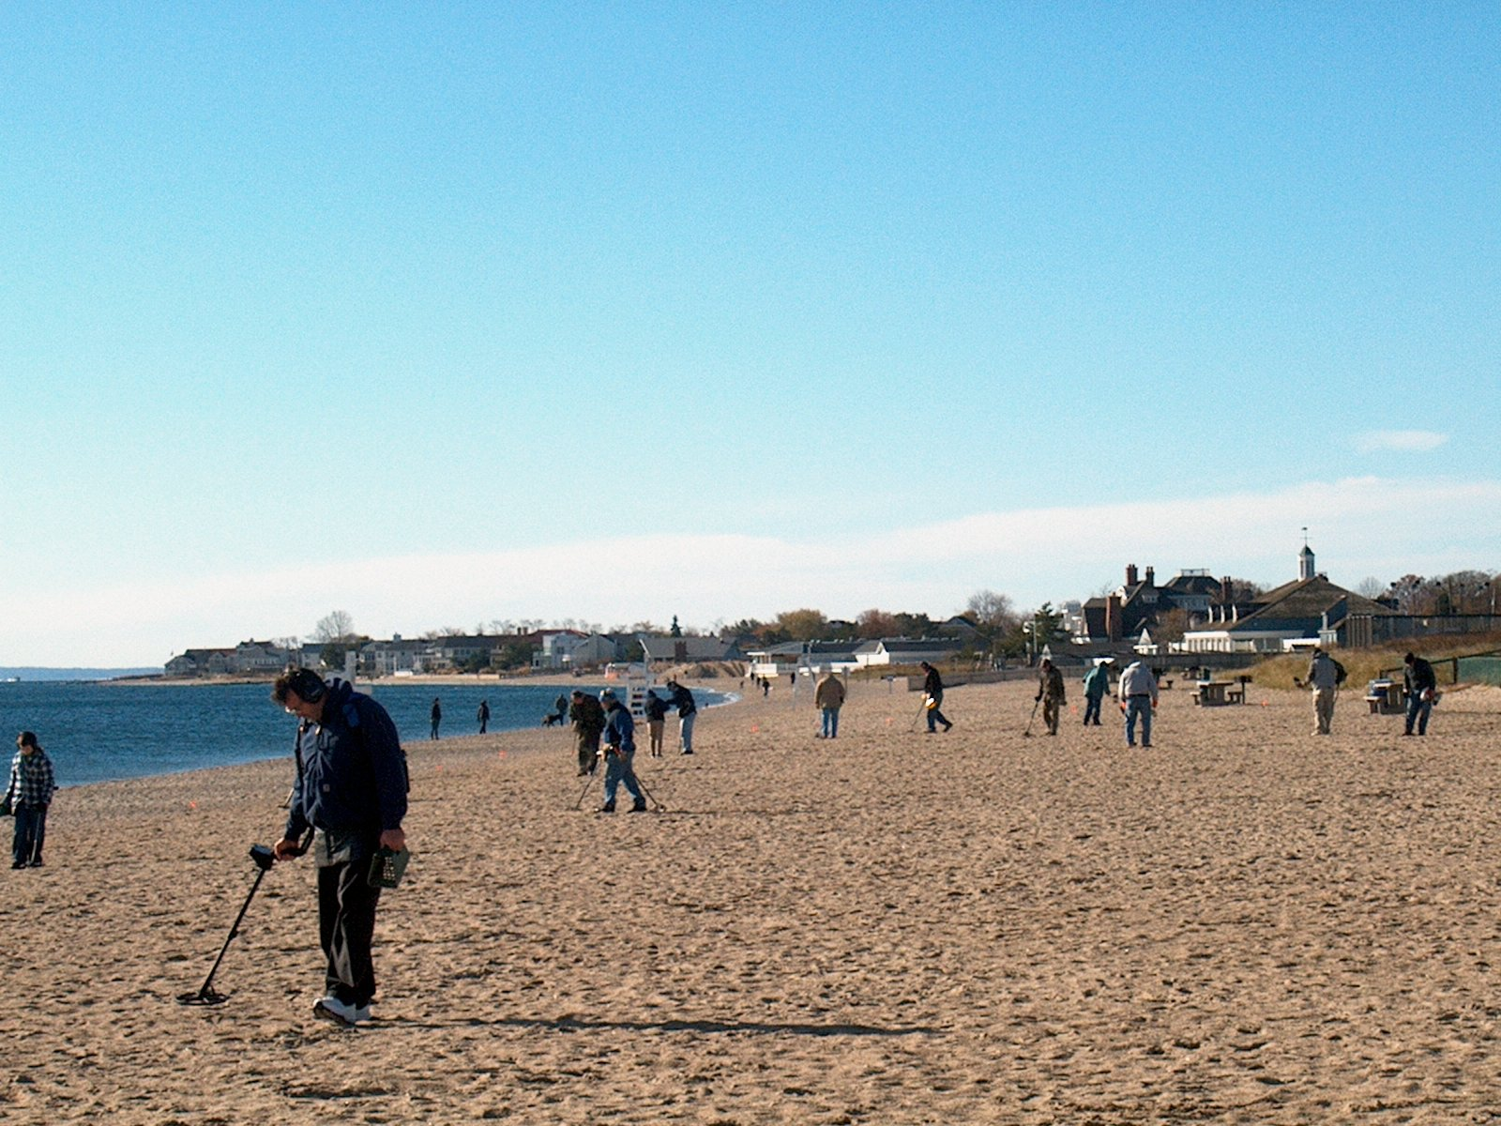

Officers

President

Ted Izzo

Vice President

Rich Markert

Putnam/Westchester Metal Detectorists and Archeological Society

Secretary
Don Mayers

Treasurer
Larry Cohen

Librarian
Lauren Bufi-Olsen

Finds of the Month
Todd Olsen

Site Research Coordinator

TBD

Newsletter Editor
Carol Mayers

Webmaster
Paul Maloney
.

Unlike the P/WMDAS Christmas Party which historically attracts cold, snowy, wet, weather this year's Fall Classic continued a long tradition of clear (if chilly) sunny weather. Twenty four contestants along with 6 crew members turned out for the long awaited annual event. Over $600.00 in gold and silver coins plus "V" nickels and Indian Cents were available to those in the search. In addition, this year a roll of Presidential Dollars was added to the mix along with some fine crotal bells donated by Tod and Lauren Olson. The competition was divided into two distinct hunts. The first targeted pennies and nickels planted in the sand of Jennings Beach along with the contents of a full roll of Presidential Dollar coins. The second hunt was for tokens redeemable for Barber dimes, quarters and halves. A large brass token was the prime target since it was good for a 1/10th oz American Eagle gold coin. Tokens were used as gold and silver had reached record highs at hunt time and no coins were about to be left in the sand. Several contestants dug more than 10 tokens each and Conrad Rasinsky was the hunter skilled enough to recover THE GOLD. This year we ran only one raffle with Vitaly and Sue Olmelchenko winning the Morgan Dollar.

Since the concept of having this event run by Committee proved to be unpopular with the membership this year's event took on a format quite divergent from past years. Refreshment took the form of "pot luck" dishes along with hot dogs and hamburgers cooked on an open fire. The response to the pot luck was most gratifying. There was an abundance of potato salad and macaroni salad. Salsa and chips proved very popular along with a hot box of Joe from D&D. Cookies and home made cake along with chocolate muffins rounded out both the menu and a few waist lines.

Special thanks go to Al Contis for his effort in providing the gold coin at a very affordable price.

Don Carter, Rich Markert and Carol Mayers did most of the cooking and no complaints were heard. Kudos also to Paul Maloney and President Ted Izzo

for organizing, flagging and seeding the event. Next year how about some chili

and baked beans? See you at the

Christmas Party.

P/WMDAS Goes To ADT
The weekend of November 13th&14th found 4 members of the Putnam/Westchester club enjoying the fruits of the mighty labors of Barry Small and his Artifact Detecting Team. We were privileged to be hunting a pair of potato fields secured for metal detecting by Barry and his crew of workers. Wildlife was in abundance and the weather fantastic. While our contingent did not recover enough quality finds to win the Find of the Weekend competition we were lucky enough to come away with some recoveries of note. Among these were a number of musket balls and old coins. Perhaps the most notable being a George II halfpence dating to 1729-1739. Buttons were popping up in good numbers. There was a nice mix of pre and post rev. war flat buttons mostly domestic in nature. One small cuff button is waiting for professional identification. It appears to be military and it is hoped to be of War of 1812 vintage. Other items of interest which were found were a crotal bell and pewter spoon (broken) dating to the early 1700's.
Detectorists from other clubs or those working independently also made some terrific finds. Best of the Weekend was a Spanish silver cob from the 1600's. Silver finds included a 1/2 reale,1877 Half Dollar, Liberty Seated quarter and a Mercury Dime. It was estimated that more than 20 US large cents and colonial coppers were dug along with at least one flying eagle cent. The heavily fertilized soil took a heavy toll on many of the relics recovered. That, along with 100s of years of plowing, made condition a real issue. Nevertheless nearly everyone present came home with one or two keepers.
P/WMDAS members who have not joined ADT are strongly urged to send in their membership dues and to register for one of the future hunts. Barry has come up with a number of potentially very productive sites. Since we as a club have been unable to acquire a new Site Coordinator it makes perfect sense to take advantage of the properties that Barry has obtained for us. If you snooze you loose. Check out the ADT web site for more information http://www.southamptonhistoricalmuseum.org/ .

2010 P/WMDAS Christmas Party Shatters Record

For the first time in Club history the annual P/WMDAS Christmas Party came and went without a snow fall! Cold, yes, but no ice, no sleet, and NO snow. All but 3 members who had registered for the event were able to attend with no travel complications. The raffle was a great success both financially and spiritually as many great prizes were awarded to the lucky winners. Among the most coveted items were the sonic cleaner won by Web Master Paul Maloney and the Whites MXT detector carted home by President Ted Izzo.
Our organization was well supported by donations from American Digger Magazine, Lost Treasure Magazine and Ed Zehall of Valley Coins. Member and Tesoro dealer Joe Snow
was most generous with donated items. Several other anonymous members also gave prizes to the point where the display table was overflowing. Among those supplying discounted items were Whites of Long Island, KellyCo and Detector Pro. To all we send our thanks and best wishes.

While for the most part the evening went very well the event was not without issues. For those members who found it necessary to stop at MacDonalds on the way home we hope the Mac Rib was satisfying. The time to start planning for 2011's Party is NOW. The organizers will do everything necessary to insure that the banquet is all that it is advertised to be.

Treasure in the News

Museums in bid for nation’s most important gold horde

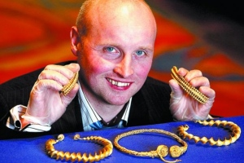Safari park worker David Booth with the 2000-year-old haul he unearthed. Pic: Gordon Terris
Phil Miller, Arts Correspondent
16 Oct 2010
Scotland’s national museums has launched a bid to raise the £460,000 needed to secure a hoard of Iron Age gold found in a Stirlingshire field by a metal-detecting enthusiast.
David Booth, 36, a safari park keeper, had owned his metal detector for only five days when he discovered four 2000-year-old gold neck bands, or torcs, last year.
Dating from between the 1st and 3rd century BC, the bands represent the most important hoard of Iron Age gold found in Scotland to date.
National Museums Scotland (NMS) has until the end of April next year to raise the money so it can receive the torcs.
The Queen’s and Lord Treasurer’s Remembrancer, Catherine Dyer, who governs the management of treasure trove finds, yesterday said she was “minded” to allocate “Scotland’s most outstanding treasure trove find” to NMS, if it meets the ex-gratia award of £462,000 to Mr Booth.
The torcs are currently owned by the Crown – under Scots law, it can claim any archaeological objects found in Scotland.
Finders have no ownership rights and must report any objects to a treasure trove unit.
The collection consists of two ribbon torcs (a local style of jewelry made from a twisted ribbon of gold), half an ornate torc of southern French origin, and a braided gold wire torc which shows strong influences of Mediterranean craftsmanship.
Last night Mr Booth, who works at Blair Drummond Safari Park, near Stirling, said he was “over the moon” about the valuation, but that it would not change him or his family’s life too much. He will stay at his post, looking after animals in the park, but the money will come in useful.
“I had no idea of the valuation till this morning. It’s not a bad return on the detector and earphones, which were £250,” he said.
“It will make life a lot easier, we are planning to pay off our debts, and have a house without a mortgage. When you go out with a detector you don’t expect to find something like that.
“I had a niggling doubt when I found them that they may not be that important, that they may even be children’s costume jewelry or something, so I was delighted to find how important they are.”
Experts at the NMS are keen to secure the treasure, which they believe is of international and national importance. The museums are already exploring different avenues to raise the considerable sums involved.
If the NMS cannot raise the money by the deadline, the Crown will reconsider its options and the payment to Mr. Booth may be postponed.
Dr Gordon Rintoul, director of National Museums Scotland, said: “We are delighted that we will now have the opportunity to acquire [the torcs] for preservation and display.
“In the context of the current difficult economic climate, we will be exploring a range of sources of funding to secure what is a substantial sum to ensure these items remain available for future generations within the national collections.”
Ms Dyer said: “I am pleased to announce that if National Museums Scotland in Edinburgh meets the ex-gratia award which would then be payable to the finder then I am minded to accept the recommendation of the Scottish Archaeological Finds Allocation Panel (SAFAP), that these wonderful items be allocated to NMS.
“This is a very significant find, the most important hoard of Iron Age gold ever found in Scotland.
“That these stunning artifacts have been unearthed in such excellent condition after being buried for 2000 years is simply amazing.”
When the Remembrancer claims an object for the Crown, they then decide on allocation to a museum, and payment of an ex-gratia award to the finder.
This decision is taken after considering advice from SAFAP.
Professor Ian Ralston, chair of SAFAP, said: “The panel is grateful to the finder for reporting these highly important finds in good time and for the further assistance from the finder during fieldwork by the National Museum at the site of the discovery.
“This has allowed much greater understanding of the archaeological context of these four exceptional items.”
Finds of the Month October 2010
USA Silver Coin – 1912 Barber Dime – John Condon
USA Non-Silver Coin – 1795 US Large Cent – Roy Roos
Foreign Silver Coin – 1785 Spanish 2 Reale – Roy Roos
Gold Jewelry - 14K Gold Ring w/Diamond – Mike Spasiuk
Silver Jewelry – 1885 Money Token – Carol Mayers
Button – Colonial Cloak Button – John Condon
Token – Central Café’ Token- Roy Roos
Relic –Brass Lock –Karl Johnson
Finds of the Month November 2010

USA Silver Coin - 1835 Capped Bust Dime - Roy Roos

USA Non-Silver Coin - 1868 2 Cent
Piece - Carol Mayers

Foreign Silver Coin - 1839 Turkish 1/2 Dime - Don Mayers

Foreign Non-Silver Coin -William III 1/2 pence - Don Mayers

Gold Jewelry - Diamond Ring / Tiffany Necklace - Tie - John Condon / Conrad Rasinski

Silver Jewelry - Sterling Silver Bracelet - Conrad Rasinski

Token - Sing, Sing Prison
Token - Roy Roos

Relics –
Crotol Bell - Roy Roos

Medal - Virgin Mary Miraculous Medal - Conrad Rasinski

Call for Classified Ads
Have equipment you are looking to buy, sell, or swap? Want to arrange a car pool to the Membership Meetings? Run your metal detecting-related classified ads in the Hudson Valley Explorer (the online version is included). It’s free, and your ad will run for two issues (6 months) before it needs to be renewed. For inclusion, Please send your ad to:
Carol Mayers
73 Jackson Cove Road
Oxford, CT 06478 Or email the information to Carolmayers@sbcglobal.net Include pictures if you have them, hard copy or digital acceptable.
Support Those Who Support Us
American Digger Magazine
P. O. Box 126
Acworth, GA 30101

Lost Treasure Magazine
Box 451589
Grove, OK 74345
http://www.losttreasure.com

Western & Eastern Treasures Magazine
P.O. Box 219
San Anselmo, CA 94979
http://www.treasurenet.com
1-800-999-9718
Hudson River Metal Detectors Detector ProTM
Innovative hunting concepts since 1996
1447 Route 44
Pleasant Valley, NY 12569
http://www.detectorpro.com
info@detectorpro.com
1-845-635-3488

Minelab USA
871 Grier Dr., Suite B1
Las Vegas, NV 89119
http://www.minelab.com/consumer
1-702-891-8809

White’s of Long Island, Inc.
240 Route 112
Pachogue, NY 11772
Phone/Fax 1-631-447-7196

Snows Metal Detectors
Authorized Tesoro Dealer
1-860-488-5694 – Joe
http://stores.ebay.com/snows-metal-detectors

Kellyco Metal Detector Superstore
1085 Belle Avenue
Winter Springs, FL 32708
1(888)535-5926

Valley Coins
Ed Zehall, Owner
37A New Haven Road
Seybridge Plaza, Rt. 67
East Seymour, CT 06483
http://www.angelfire.com/planet/valleycoins/index.htm zehallco@aol.com
1-203-888-1186
Buy – sell – trade US & World Coins, Paper Money, Gold & Silver Coins, Bars & Scrap..Confidential Appointments
Mon-Wed, Fri 10am – 5pm
Thur 10am – 8pm
Sat 10am – 4pm

J-Tech Industries
Custom Welding & Fabricating
Steel, Aluminum & Stainless Steel
130 Silvermine Road
Seymour, Ct 06483
Jason Lubinski
(203)545-9828

FMDAC Treasure Hunter’s Code of Ethics
I will always check federal, state, county, and local laws before searching. It is my responsibility to know the law.
I will respect private property and will not enter private property without the owner’s permission. Where possible, such permission with be in writing.
I will take care to refill all holes and try not to leave any damage.
I will remove and dispose of any and all trash and litter that I find.
I will appreciate and protect our inheritance of natural resources, wildlife, and private property.
I will, as ambassador for the hobby, use thoughtfulness, consideration, and courtesy at all times. I will leave gates as found.
I will build fires in designated or safe places only.
I will report to the proper authorities any individuals who enter and/or removes artifacts from federal Parks or state preserves.
Metal Detecting Permit Information
Take the time to renew your permits now for Spring! See the list of locations where you may send to receive yearly metal detecting permits below. If possible, call first for any updates or instructions.
1. Palisades Interstate Park Commission Permit Section Bear Mountain, NY 10911-0427 ..................................$20.00 For: Harriman State Park (845)-786-2701
Lakes: Sebago, Tiorati & Welch
2. Long Island State Park Region Beaches Permit Office PO Box 247 Babylon, NY 11702.…………..……...…..$40.00 (631)-669-1000 ext. 223
3. City of New York Parks & Recreation Arsenal North 234 Fifth Ave. Room 213 New York, NY 10029.…...........................….FREE (212)360-2778
(MUST SEND IN COPY OF YOUR DRIVERS LICENCE)
4. Office of Parks, Recreation & Historic Preservation Taconic Region Staatsburg, NY 12580....................................$10.00 (845)889-4100 For: Lake Taghkanic, Rudd Pond & Canopus Beach
5. NY State Offices Parks Recreation & Historic Preservation Central Region 6105 East Seneca Turnpike Jamesville NY 13078-9516 …$10 (315)-492-1756
Tentative Schedule of Events for 2011*
*contingent on finalization of search agreement
Thursday, February 3, 7:00pm
Membership Meeting, Yorktown Heights, NY

Thursday, March 3, 7:00pm
Membership Meeting, Yorktown Heights, NY

Thursday, April 7, 7:00pm
Membership Meeting, Yorktown Heights, NY

Saturday, April TBD, 9:00am Search Outing TBD

Thursday, May 5, 7:00pm
Membership Meeting, Yorktown Heights, NY

Saturday, May TBD, 9:00am Search Outing TBD

Thursday, June 2, 7:00pm
Membership Meeting, Yorktown Heights, NY

Saturday, June TBD, 9:00am Search Outing TBD

Thursday, September 1, 7:00pm
Membership Meeting, Yorktown Heights, NY

Saturday, September TBD, 9:00am Search Outing TBD

Thursday, October 6, 7:00pm
Membership Meeting, Yorktown Heights, NY

Saturday, October TBD, 9:00am Search Outing TBD

Thursday, November 3, 7:00pm
Membership Meeting, Yorktown Heights, NY

Saturday, November 5, 10:00am *
Rain Date November 6
Fall Classic Seeded Hunt, Fairfield, CT

TBD, December TBD, 7:00pm Annual Christmas Party
Location to be Determined

